Reg. No. CODE: SPH1

PH.D COURSEWORK EXAMINATION, MAY 2023
SUBJECT: CHEMISTRY
SPECIALIZATION PAPER I - CHARACTERIZATION TECHNIQUE
Time: 03 hours Maximum Marks: 50
Student Name: Ms. Rachel Chetri

Instructions:
- Section A Compulsory
- Answer any four from Section B
- Each question carries 10 Marks

Part - I

- Discuss the importance of UV-Visible absorption spectroscopy and photoluminescence spectroscopy in organic chemistry. How are these spectroscopic methods useful in your current research? Explain. (10)

Part – II
- a) Match the following groups with their characteristic frequencies in IR spectra.
          - O-H (primary alcohol) (I) 1220-1020 cm⁻¹
          - -CH₃ (hydrocarbon) (II) 2220 cm⁻¹
          - C=O (aliphatic aldehyde) (III) 3630 cm⁻¹
          - >C=O (IV) 1730 cm⁻¹
          - C-N (aliphatic amines) (V) 1750 cm⁻¹
          - C-I (organo iodine compounds) (VI) 1690 cm⁻¹
          - C≡N (nitrile) (VII) ~500 cm⁻¹
          - C=O (saturated ester) (VIII) 2900 cm⁻¹

b) Explain hypsochromic, bathochromic, hyperchromic and hypochromic shifts in UV-Vis spectroscopy. (8+2=10)

- What is a Jablonski diagram? How to interpret a Jablonski diagram? Draw the Jablonski diagram showing the possible radiative and non-radiative transitions and explain in detail. (10)

- a) Explain the instrumentation of NMR spectroscopy with a schematic diagram. b) Identify and explain the following bands in the proton NMR of benzoic acid. (5+5=10)
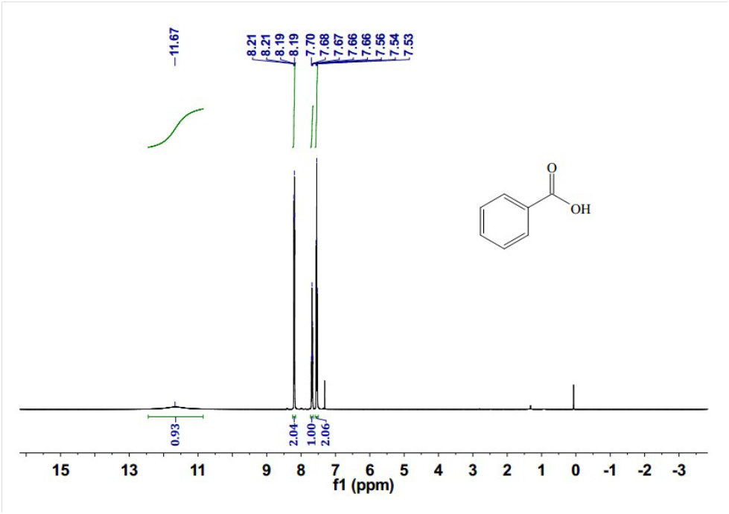

- a) Show how you would distinguish between propanal and acetone using NMR spectroscopy. Label the axes properly and schematically show all the important features in the spectrum. b) Explain Retro-Diels-Alder reaction and ortho effect. (6+4=10)
- Explain the principle, instrumentation and applications of cyclic voltammetry. How does this technique help to determine the HOMO-LUMO energy levels and band gap of an organic molecule? (10)

*********

